**PROJECT REPORT TEMPLATE**

## **1. INTRODUCTION**

**1.1** Overview

India is the world's third-largest producer and third-largest consumer of electricity. The national electric grid in India has an installed capacity of 370.106 GW as of 31 March 2020. Renewable power plants, which also include large hydroelectric plants, constitute 35.86% of India's total installed capacity. During the 2018-19 fiscal year, the gross electricity generated by utilities in India was 1,372 TWH and the total electricity generation (utilities and non-utilities) in the country was 1,547 TWH. The gross electricity consumption in 2018-19 was 1,181 kWh per capita.

## **Purpose**

* Electric energy consumption is the form of energy consumption that uses electrical energy.[1] Electric energy consumption is the actual energy demand made on existing electricity supply for transportation, residential, industrial, commercial, and other miscellaneous purposes.

* Global electricity consumption in 2019 was 22,848 terawatt-hour about 135% more than the amount of consumption in 1990. China, United States, and India accounted for over 50% of the global share of electricity consumption.

* Heating and cooling our times, lighting office buildings, driving cars and moving fright, and manufacturing the products we rely on in our daily lives are all functions that require energy.

**2. PROBLEM SOLVING & DESIGN THINKING**

2.1 Empathy Map

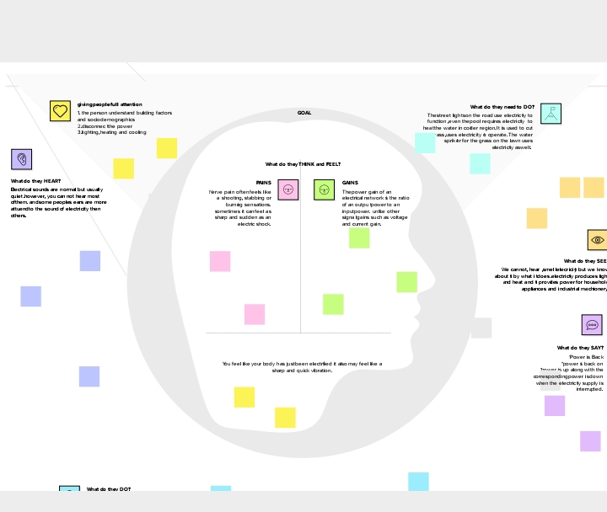

## **2.2 Ideation & Brainstorming Map**

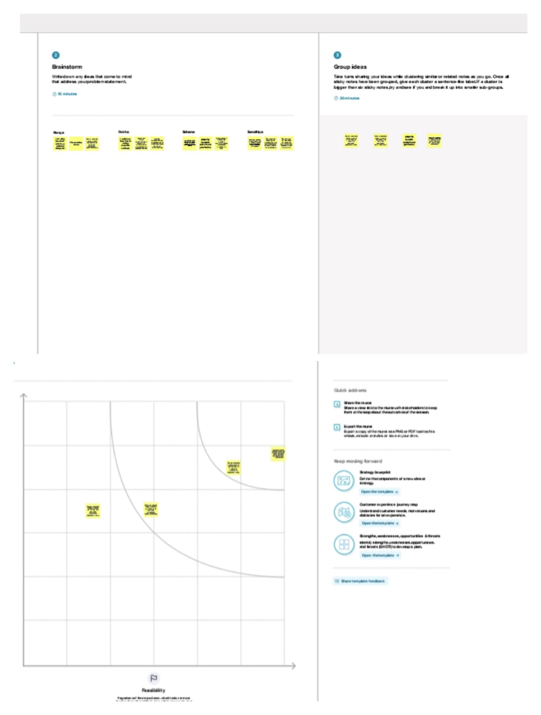

## **RESULT**

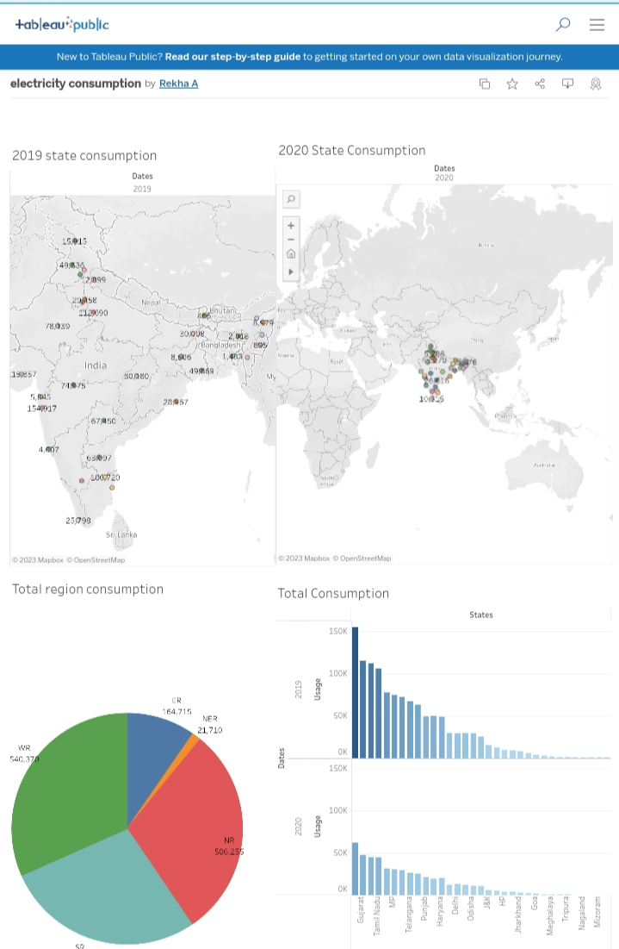

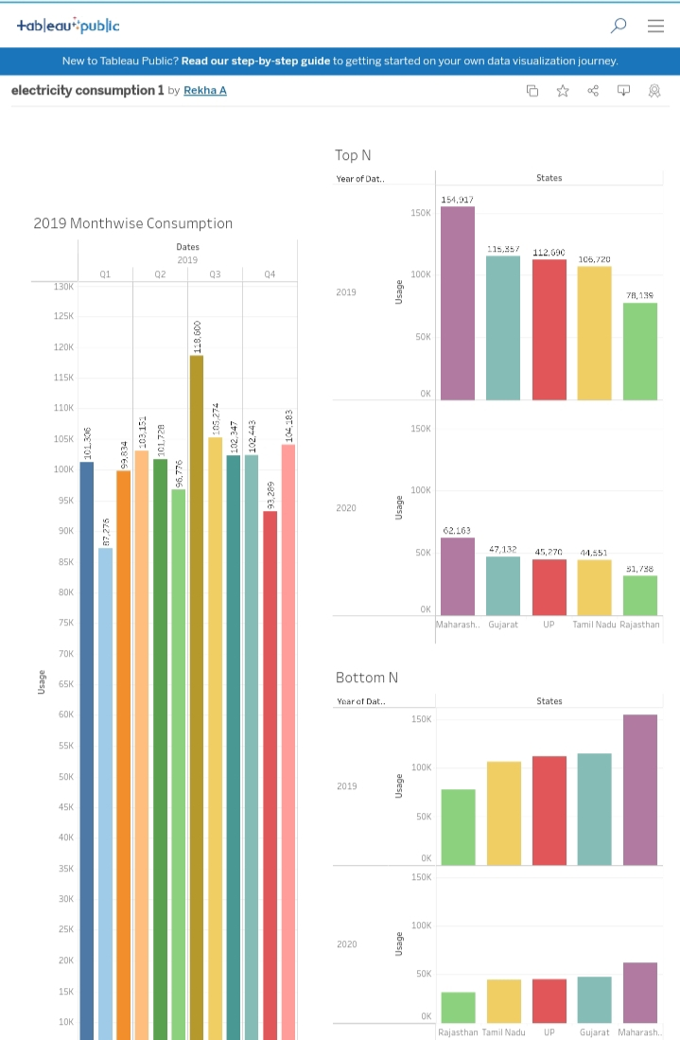

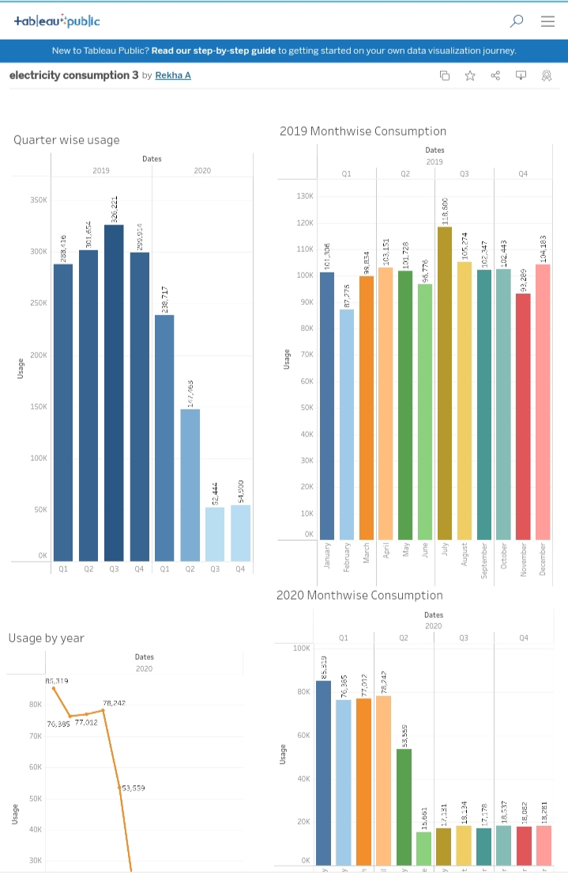

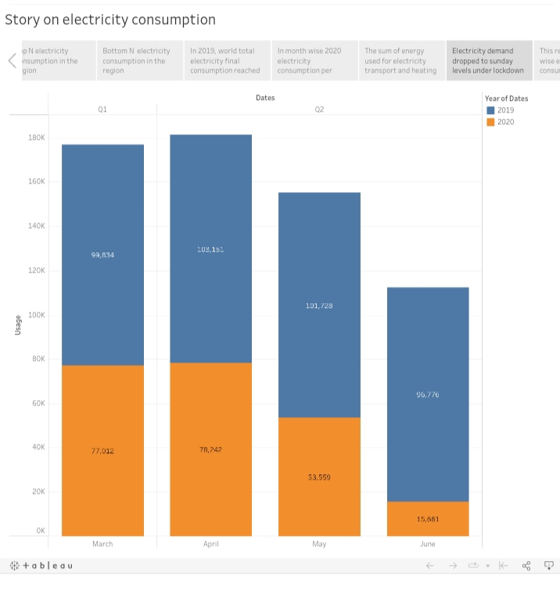

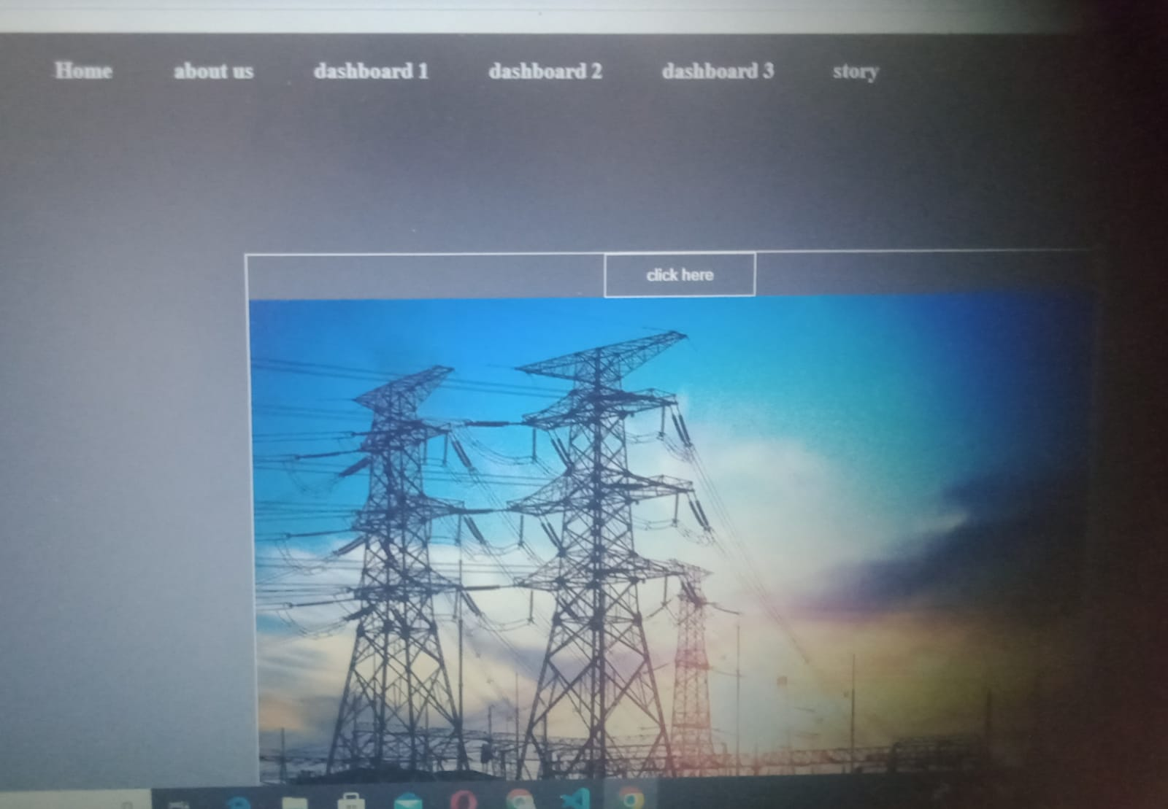

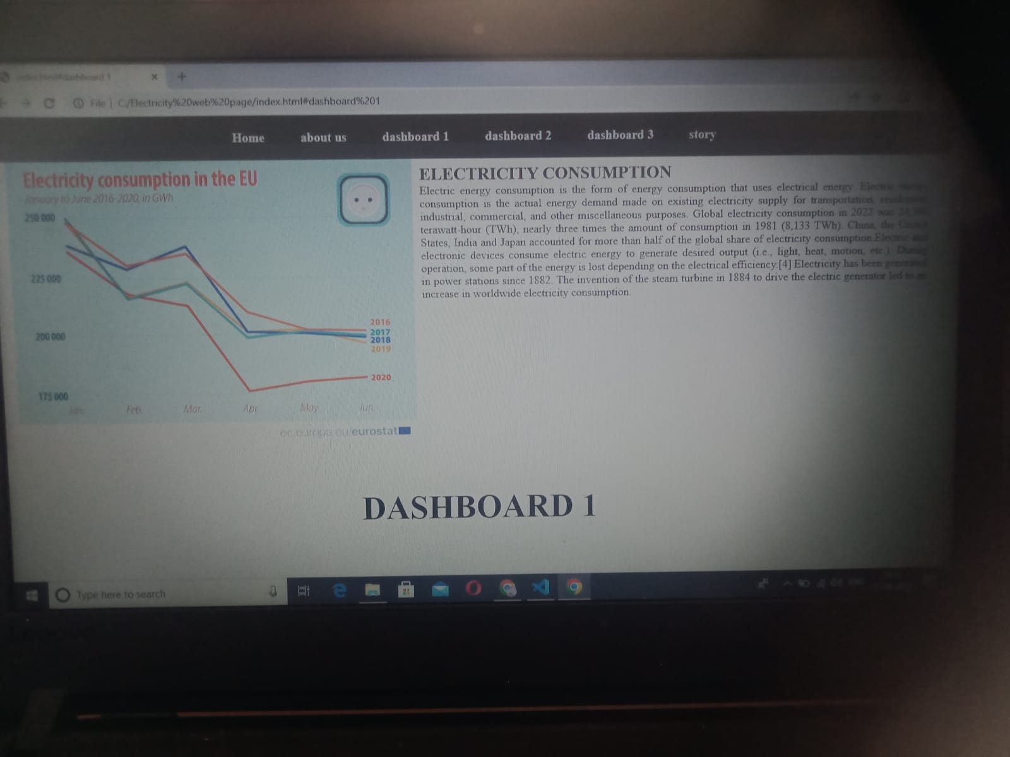

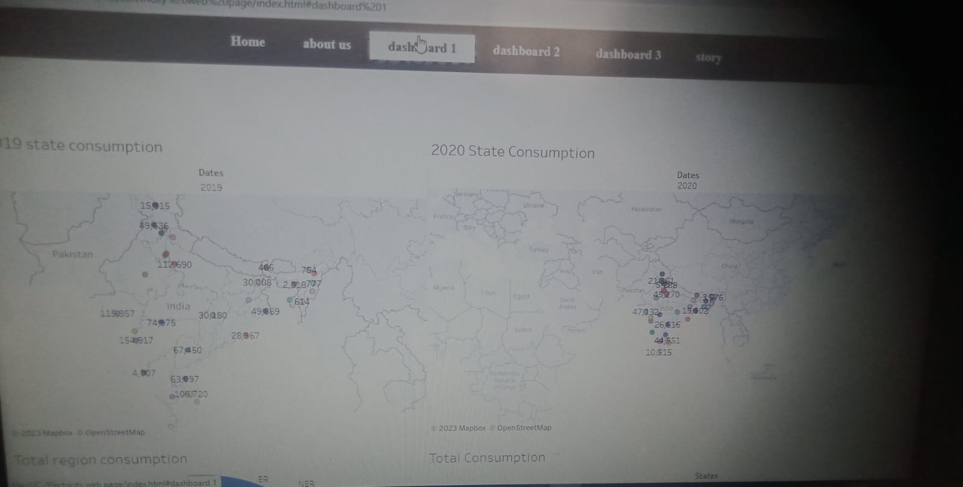

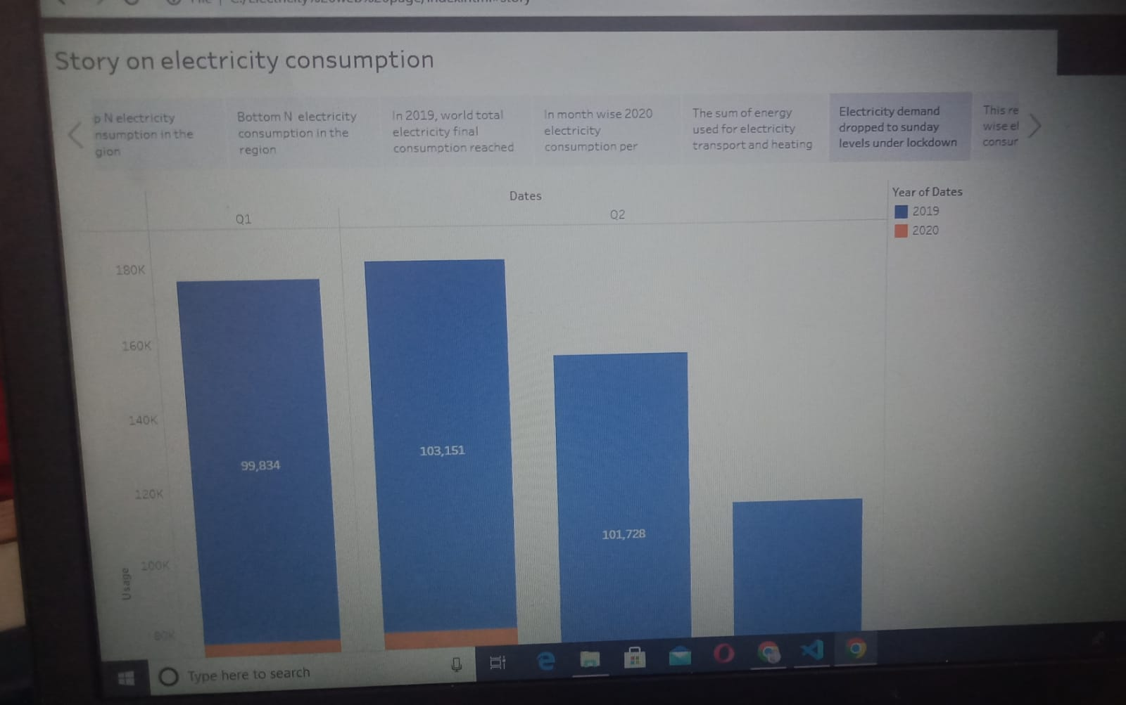

1. **ADVANTAGES**

Annual electricity consumption per capita serves as an important measure of a country's electric power development. Generally speaking, electricity consumption grows faster when the industrialization process develops quickly and goes down rapidly when industrialization is completed or near completion.

**DISADVANTAGES**

* More expensive than gasoline

*Loss of fish species

*Sometimes messes up wildlife

*Dependent on precipitation

* More power plants and more pollution

*Damming can cause loss of land suitable for agriculture as well as recreation

**5. APPLICATIONS**

*We use electricity in various household devices. Along with this, in the near future, electrical energy can also be used for transportation on a broader scale. Few real-life applications of electrical devices are as follows.

*Let's understand the scope of utilization of electrical energy with mini experiments.

*Some electrical devices work on the principle of heating effect of current likes Iron, Heater and many more. Let us understand how they work.

**6. CONCLUSION**

Energy conservation, in addition to lowering energy costs, can benefit the environment in a variety of ways. For starters, energy conservation can protect the environment by reducing resource consumption and carbon dioxide emissions. Following that, energy conservation can reduce the need for new power plants.

**7. FUTURE SCOPE**

Prior to the global pandemic, India's energy demand was projected to increase by almost 50% between 2019 and 2030, but growth over this period is now closer to 35% in the STEPS, and 25% in the Delayed Recovery Scenario.

**---------END--------**